review of graduate destinations and outcomes data – working group 4

24 October 11:00 – 25 october 14:30

HESA OFFICES, 95 the promenade, cheltenham, gl50 1hz

paper no: 1

Skills

The consultation asked respondents to consider introducing a skills-based measure in NewDLHE.

Figure 1 Count of responses to question 74

Figure 2 Count of responses to question 74 by question two.
Themes from the free text responses were:
- Use UKSES model (7)
- Keep short and simple (9)
- Make skills specific to the course undertaken (3)
- Focus on core skills which are applicable to most types of employment (13)
- Use SHL’s great 8 (1)
- Use Longitudinal DLHE section F (2)
- Ask of those in further study too (3)
- This measure requires graduates to be self-reflective (15)

questions for the working group
- Is there a mandate for this?
- What is the approach we will take?
- What skills framework should we use?
- Which activities are we asking this for?

Potential models
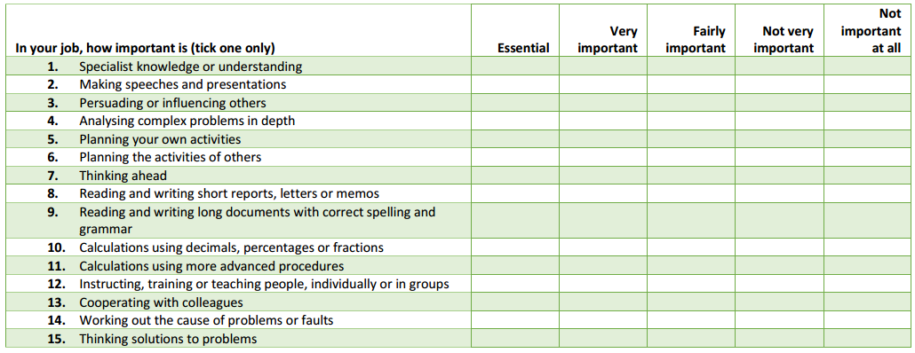
Figure 3 UKSES extended question set
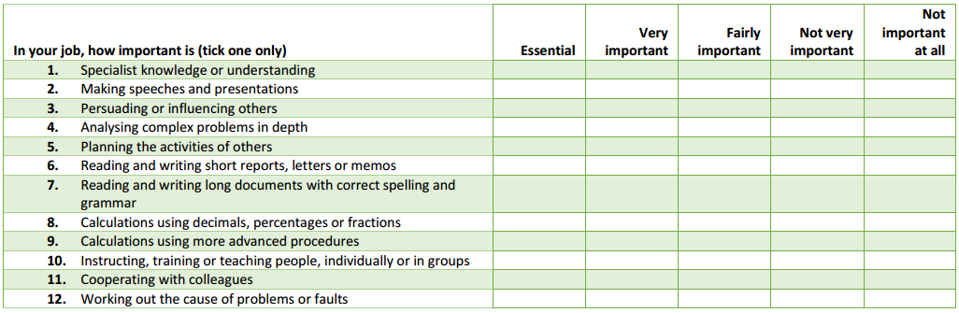
Figure 4 UKSES reduced question set
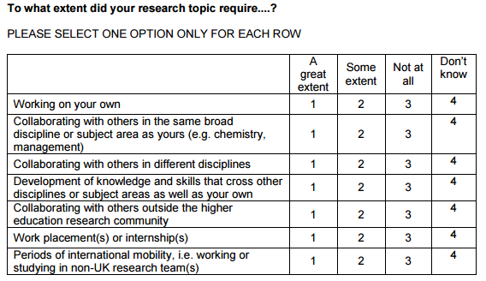
Figure 5 Longitudinal DLHE Question 52
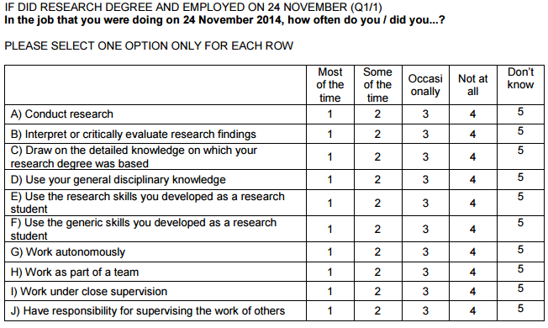
Figure 6 Longitudinal DLHE Question 53
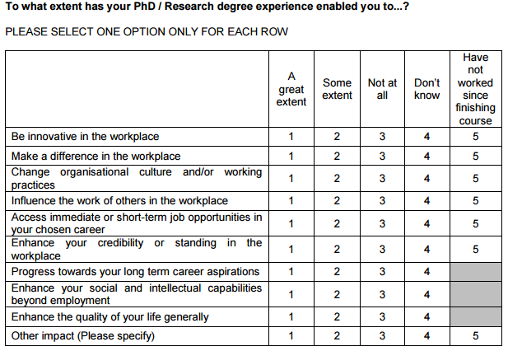
Figure 7 Longitudinal DLHE Question 54
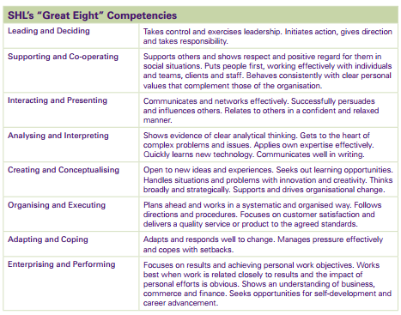
Figure 8 SHL's "Great Eight" Competencies

