review of graduate destinations and outcomes data – working group 4

24 October 11:00 – 25 october 14:30

HESA OFFICES, 95 the promenade, cheltenham, gl50 1hz

paper no: 3

Placements, work-based learning and work-related learning

Placements/Work-based learning

Figure 1 Count of responses to question 88

Questions for the working group
- Is there a mandate for this?
- What is the approach we should take?

Potential definitions
ASET
Placement definition: Placement learning is when the learner might be considered as student first, employee second; i.e. they came to the placement experience by virtue of their studies

Work-based learning definition: Work based learning is when the learner might be considered as employee first, student second; i.e. they came to the Higher Education experience by virtue of their employment or employer
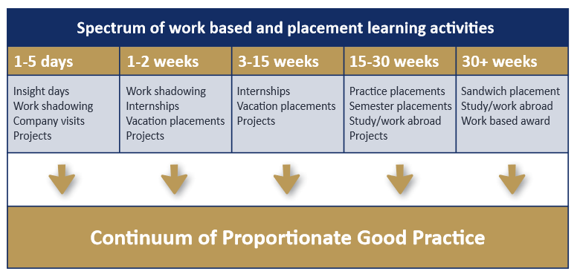
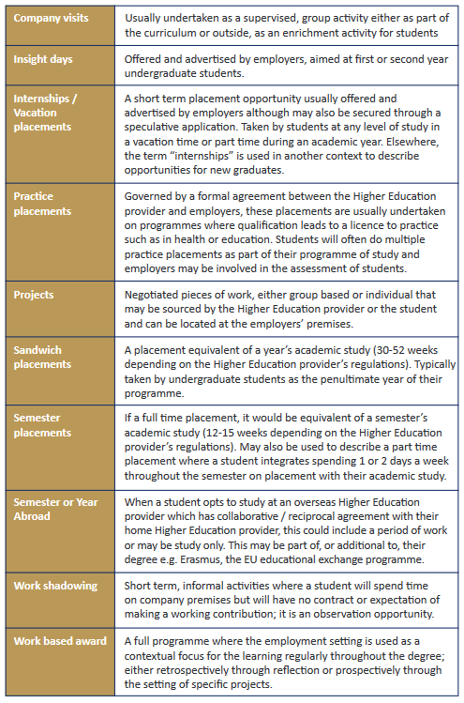
QAA
Work-based learning definition: Work-based learning (WBL) provides the reality of an authentic context for learning which produces the currency of transferable credit. It can enrich student learning, create a well-qualified workforce and open up new markets for HEIs.
The term work-based learning includes a wide range of provision where the focus is on situations where the main location for the student is the workplace. The curriculum meets the needs of both HEI and employer and is jointly planned, delivered and assessed. It uses the immediacy of the work context to provide practice and to encourage reflection on real issues leading to meaningful applicable learning.
The following cases are included in our definition of WBL.
- Employee-students in vocational areas undertake professional qualifications part-time using their work context as a key component of their learning.
- Employee-students undertake general degree studies using their work context for learning and assessment.
- Workers undertake in-house courses that are then credit-rated towards HEI awards.
- Workers undertake programmes deliberately planned to integrate learning and practice.
The following cases are not included in our definition of WBL.
- HEI courses that send students out on block placement.
- Students take an internship module within industry as part of their degree.
- Workers study by distance learning, evening class, day release, block release or blended learning which is not linked to the work context.

Work-related learning

Figure 2 Count of responses to question 92

Questions for the working group
- Is there a mandate for this?
- What is the approach we should take?

