review of graduate destinations and outcomes data – working group 4

24 October 11:00 – 25 october 14:30

HESA OFFICES, 95 the promenade, cheltenham, gl50 1hz

paper no: 4

Alternative measures of graduate outcomes

The consultation asked whether we should find new measures for graduate outcomes:

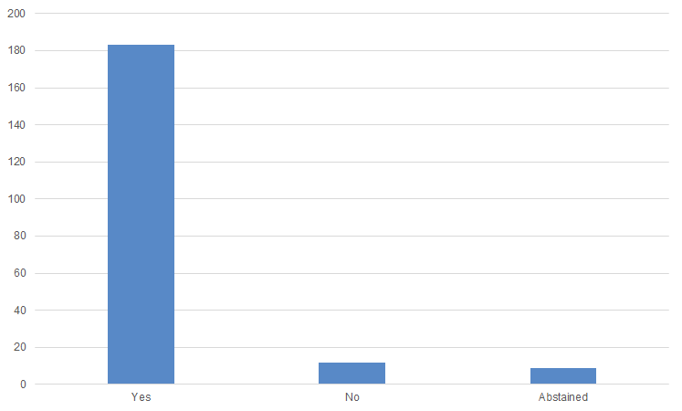
The consultation also asked respondents to consider the benefits of a range of alternative measures of graduate outcomes in NewDLHE.

Themes from the free text responses on skills for life were:
- This is important evidence from HE (38)
- Useful for less vocational courses (5)
- Too dependent on the self-reflection of graduates (26)
- There should be more than one question (9)

Themes from the free text responses on links to previous surveys were:
- It is difficult to compare between different unique surveys (32)
- This would offer a baseline to compare to (15)
- Likely to be costly/burdensome (25)

Themes from the free text responses on student engagement were:
- Engagement doesn’t necessarily equal good destination (12)
- Helps to understand how HE employability measures work (21)
- Depends how you define/measure it (24)
- Lower priority than other measures (3)
- Should be captured through NSS/other surveys (18)
- Link to UKES (25)

Themes from the free text responses on subjective wellbeing were:
- Take the ONS approach (3)
- Important factor in graduate outcomes (53)
- Subjective measure which is too reliant on external factors (55)
- Need comparable data pre-university/on entry to compare (17)
- A measure which providers cannot influence (20)

Themes from the free text responses on net promoter score were:
- Include an option to ask why they scored that way (7)
- Too blunt a tool for this complex issue (19)
- Too subjective (22)
- Simple effective measure (18)

Net promoter score question options
The consultation asked respondents to provide the precise wording of the net promoter score question they would prefer:
- How likely are you to recommend - to a friend (27)
- How likely are you to recommend - to a prospective student (12)
- How likely are you to recommend - to a colleague (10)
- How likely are you to recommend - to others (6)
- How likely are you to recommend your university to – (36)
- How likely are you to recommend your course to – (26)
- How likely are you to recommend your HE experience to – (3)
- How likely are you to recommend - to - for employability (21)

subjective WELL-BEING QUESTIONS
The ONS subjective well-being questions are:
- Overall, how satisfied are you with your life nowadays?
- Overall, to what extent do you feel the things you do in your life are worthwhile?
- Overall, how happy did you feel yesterday?
- Overall, how anxious did you feel yesterday?
Scale: People are asked to respond on a scale of 0 to 10, where 0 is “not at all” and 10 is “completely”.

Questions for the working group
- Is there a mandate for this?
- What should be the principles underpinning our approach?
- What other advice should we take on board?

