review of graduate destinations and outcomes data – working group 4

24 October 11:00 – 25 october 14:30

HESA OFFICES, 95 the promenade, cheltenham, gl50 1hz

paper no: 5

Centralisation

Strategic Group guidance
The Strategic Group advised us to task the Working Group with producing an implementable design for centralisation, that prioritises obtaining the highest-quality contextualising data, while addressing HE providers' practical concerns.
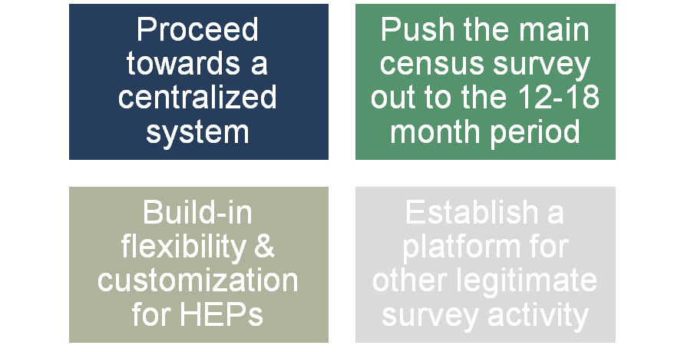

Feedback from the consultation
Respondents to the consultation were asked to consider pros and cons of moving to a centralised approach.

Arguments in favour of centralisation
- Standardisation / levels the playing field– agreed approaches to when students are contacted, how and how often.
- Centralisation of SOC coding avoids issue with these in terms of robustness of the structure of the coding frame and also different individuals trying to attach jobs to SOC codes.
- Data can be linked publicly
- Provides confidence in own results
- TEF makes the need for outsourcing stronger than ever.
- Consistency in centralisation whereas distributed could be inconsistent (bias)
- Governance of outsourcing return incomparable to in house
- Allows data to retain national statistics classification

Arguments against centralisation
- What impact will centralisation have on response rates?
- HE providers need access to granular DLHE data
- DLHE process fits within others processes in providers
- What does centralisation do to after-care and HEPs maintaining relationships with graduates. Would HEPS feel removed from the process and not want to engage?
- Needing to do DLHE is a prompt to keep up to date with leavers.
- Centralisation might favour certain types of providers
- Graduates may not trust a third-party data collector with sensitive personal data
- Providers currently use the DLHE collection period to pass on additional information to their graduates, e.g. careers or alumni contact. This is unlikely to be possible through a centralised survey and might lead to them having to recontact graduates.
- Information about the graduate which is gained from others across the HE provider, such as academics/tutors, will be lost
- Data quality may be impacted by a third party supplier collection

Questions or suggestions raised on centralisation
Consultation respondents and the strategic group raised areas for further consideration:
- Would leavers answer more honestly to a 3rd party?
- Could there be fusion options? New DLHE could work well under a similar framework to PRES/PTES, so could be run by HESA and administered through a survey provider. There could be a core contract which HESA could go to tender for, then each HEP would have a separate contract with this provider so they could ask further questions of interest. There could be an agreed price for the basic or ‘core’ survey and then have plug-ins.
- How will the provider get access to the data?
- What influence will providers have on the data?
- Would this be full or partial centralisation?
- Use of WebHub to monitor and control responses
- What would the cost entailed be for providers if partial centralisation? Would project teams be designated for this?
- Highly skilled telephone operative for surveying students would be beneficial, as more detailed information is gained this way
- Weekly SOC coding could be returned to HE provider through an outsourced model. Notes should be kept explaining decision making for audit. Live environment rather than gathering and then submitting for coding. Support from universities or subject experts to assure coding.
- Process should retain auditing if outsourced
- Some form of personalised communication from provider to the graduates could be used to promote and encourage response rates
- Method of collection doesn't matter to data users as long as it robust
- Procurement specialists need to be involved in the process
- HE providers need to be reassured that their concerns are being met
- Centralisation would benefit from starting from year zero.
- Ability for ‘add-ons’ from main survey provider is important as each provider has their own needs. For example, the OU currently contact graduates or 1-3 years and would be useful to use a new survey provider for this. It was noted that any appended questions can’t compromise the ‘core’ survey in terms of getting NewDLHE the Nat Stats accreditation.
- How will this impact overseas students?
- A third party system would need to be operated under a single provider for consistency.

Question for the working group
- What principles should underpin a centralised approach?
- How can the design of a centralised platform address HE providers' practical concerns?

