Review of HE student destinations and outcomes data:
Third working group meeting

Monday 22 February 2016, 11.00am
Finlaison House, London, EC4A 1AB

Paper No: 2

Uses for higher education leavers' destinations and outcomes data

A first pass at data requirements for a replacement for DLHE
This paper draws together what we know about the current and desired future uses for data on destinations of students leaving higher education. This is a broad topic area, so our attempts are likely to be more representative than exhaustive. Our intention is that the material in this paper could inform public consultation on the next steps for the Destinations and Outcomes review. We cover each significant area of data collection in turn.
We also wish to make clear that in this exploratory phase of the Review we are considering a wide range of possible directions for future data collection. At a later stage, all ideas for change will be assessed in the light of consultation responses and other evidence, and the scope refined to leave that proportion of data items with a firm rationale for collection.

Demographic and contact information, and opt-out data
We must collect data sufficient to uniquely identify the leaver, contact the leaver, and link to other data. This will obviously be required at individual level, and is a necessity for successful responses.
Institutional records will normally be required to make first contact. HESA will maintain pre-existing opt-out information.
We need to allow for an appropriate range of further uses for the data, when drafting the opt-out statement. Forthcoming EU legislation (ESOMAR have produced guidance) appears to allow for the continuation of an ‘opt-out’ approach.
The Leaver will always be needed to update these records as no other source is definitive.

Activity
Data users need to know what activities the individual Leaver is engaging in, and which one is the ‘main’ one. We need to obtain this information at the most granular level. Linked data from HMRC, DWP and education datasets including HESA (but also FE, to allow for non-linear progression) will provide important background information. However, understanding activity has a strong qualitative element and covers areas where data are not believed to be available for linking (due to start a job, travelling, something else).
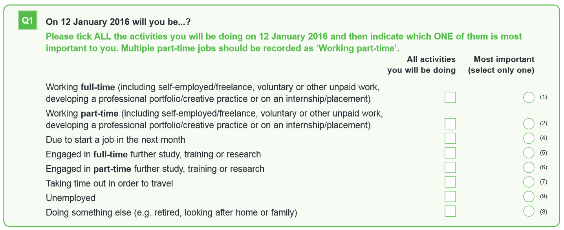
The current DLHE question in this area (Q.1) has been given careful consideration by previous reviews, and is we believe it remains broadly fit for purpose. However, the Review’s initial work has indicated that this question lacks some required granularity, particularly in some subject areas. Some amendments should therefore be explored. These could include adding items like ‘Working more than one job’ and ‘Starting my own business’, and possibly examples of non-economic work such as ‘Volunteering’ or ‘On an internship’. These are not only interesting in their own right, but could serve a practical purpose of allowing ‘routing’ of a survey to explore these areas in more depth, if required. The current DLHE covers non-employment activities relatively superficially, and we are keen to understand the appetite for changing this.
If the census date for the survey were to change, it could be desirable to gather some information about employment history. There are many options for this, depending on data users’ requirements. One source for this would be linked data. Another could be a first destinations survey of some kind. We are keen to understand more about the impact of a change in census date on data requirements.

Job title, main thing done in job, and SOC code
These data are all still likely to be required, and while we are exploring a basket of other indicators about outcomes from HE (more on which below), SOC provides an important basis for comparing graduate data with other labour market data. It is not believed that these data will be available from HMRC.
Note: ONS are currently reviewing SOC2010, on which the SOCDLHE2010 coding frame is based. We believe that in the longer term, the SOC framework requires updating to account for changes in the jobs market, which are particularly important when considering leavers from HE. We also believe that the classifications of certain roles should be moved into different major groups. There may also be benefit in severing the link between the codes themselves and the hierarchical way in which they are presented, to enable the coding framework to benefit from greater flexibility in the face of a rapidly-changing labour market. Interested parties are also encouraged to respond to ONS’ consultation, which is available at: http://www.ons.gov.uk/ons/about-ons/get-involved/consultations-and-user-surveys/consultations/consultation-on-revising-the-standard-occupational-classification-2010--soc2010-/index.html and has a closing date of 17 April 2016.
Since SOC data is now used in a range of public information products, measures of graduate outcomes are increasingly used as performance indicators both inside and outside the organisations that are collecting and coding the data. A highly-trusted process is therefore necessary in order to demonstrate the reliability of the data and to avoid accusations of bias. All users and suppliers of the data will benefit from an impartial approach that ensures national consistency in application of the methodology. We should therefore seek to reduce the possibilities for inconsistencies to arise in the coding process. This would include removing the effects of differences in experience, training and judgement on the part of staff involved in coding. Methodological improvements should be made in this area, which could include centralized coding, self-coding, or a combination of these.

Salary
Tax and benefits data can now be linked with education data under the provisions of the Small Business, Employment and Enterprise (SBEE) Act. With HMRC data available as a highly-credible source of salary data, we should not need to ask any direct questions about salary in future. This would remove one of the main causes of respondent drop-out from the survey as it is currently conducted. It would also make available a much more complete and consistent dataset that does not suffer from survey effects such as respondent imprecision.
The mechanisms for these data to be made available will not become clear from some time. While it is understood that the most granular individualized data is always preferred, data made available by the SBEE Act may also prove useful if available analysed by subject, course, gender ethnicity, and other bases. We are interested in understanding more about the analysis that data users might wish to conduct on linked tax/salary and benefits data, and the questions they might wish to answer by such analysis.
For international students, no linked data is available. We would be interested in understanding more about the appetite for collection of salary data for students employed overseas.

Employment basis and hours
These data are mainly used to contextualize salary data.
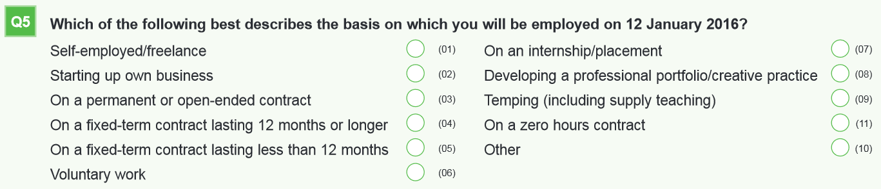
Contract type is useful to track different forms of employment and interaction with employers. We have not detected an appetite for this question to be substantially altered, but some elements could be re-defined subject to changes being made to the ‘Activity’ question, explored above.
Questions about hours of work are arguably no-longer required. Improved salary data from HMRC should make a simple full-time/part-time split sufficient for most purposes. This should also apply for leavers employed overseas, for whom these data should no longer be collected.

Employer details
Employer details are required to understand the industry in which a leaver is working, and are used to assign a Standard Industrial Classification (SIC) code, something that is currently achieved by a HESA-appointed contractor, and could continue in future.
Some areas of SIC do not appear to capture a sufficient level of granularity for a range of service industry roles, particularly in finance and business services. We would be interested in hearing a wider range of views on this point.
These data are also generally required by careers/employability services. In all cases data are required at an individualized level. There is also a desire to obtain more reference data about employers, by looking for indicators of business size/scale, and by determining the employment location (we will deal with this latter point below).
At the time of writing it is uncertain how complete and accurate employer information from HMRC will be. It may be possible that sufficient information for SIC-coding to take place will be available.
There are various reference data information sources available for organization information, but none is considered sufficiently complete to be usable at present. However, we could investigate this more fully if data users would find it beneficial.
We are interested in learning more about the types of information about employers that data users require, to help inform the Review.

Location
Location of employment is important data to understand the structure of the graduate labour market on a city and regional basis. It should be retained. Because of the complexities of group structures, franchising and outsourcing, it is not expected that these data will be derivable from HMRC, som the leaver would remain the source. Data are required at an individual level.
Information on domicile location is not currently collected, but could be added if there was a requirement to understand graduate migration in greater depth. The cost of collecting these new data would need careful justification.
There may be other possibilities to enhance locational information as discussed in the section on reasons for activity, below.

Relevance of qualifications
We currently ask two questions relating the relevance of qualifications to jobs, and these are of great interest to data users, particularly for jobs coded in SOC major groups 1 and 2.
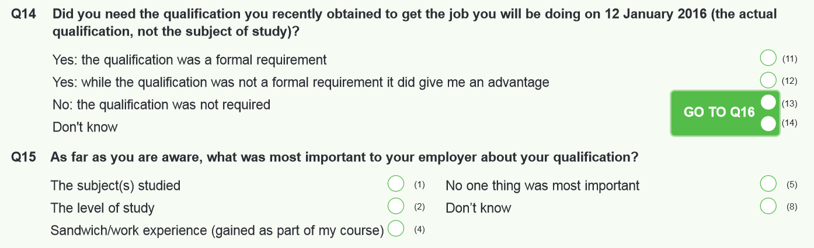
One criticism of these questions is that they could be perceived as asking the leaver for information that is in the proper domain of the employer. However, there is probably still value in a question of this kind.
One option could be to replace both of these questions with one that is properly situated in the leaver’s subjective experience. This could take something like the following form:
Was your qualification:
- essential for obtaining your current role
- helpful in obtaining your current role
- not helpful for obtaining your current role
- don’t know
For those who answer a) or b) a follow-up asking whether they think it was the level of qualification, the subject or both (or something else) that was most important.
Another criticism of the current questions is that they do not cover the relevance of qualifications to non-economic jobs or non-employment activities. Since these are reasonable motivations for study, users are missing-out on potentially valuable data. We would welcome views on this point.
Some valid entries in the current questions deal with work placements and sandwich courses. We believe that there are better ways of collecting these data, and would seek to remove them from this section. Please see the Placements section below for more detail.

Skills
The current DLHE makes no mention of skills, neither those developed during study, nor their use in employment. We consider that this now represents a serious omission, and would like to see the inclusion of skills-related questions in future. This could help improve the evidence base for discussions with employers about graduate preparedness for employment.
One potential format for a question, would be to present a selection of skills drawn from a recognized or reputable framework, and ask leavers to rate the extent to which they developed these in their studies. A further question could then ask leavers to rank the skills in the order in which they are used in the workplace.
We note that there are many skills frameworks, and that the selection of suitable skills will need to have credibility with employers. If there is broad agreement over this approach, we would seek further input from appropriate employer organisations.
In addition, we have become aware that non-experts frequently confuse attributes with skills, and care will need to be taken over this issue. We welcome feedback about this general approach, and also specifically encourage feedback around the selection of suitable employability skills.

Reasons for activity
Previous reviews have considered the current DLHE question 16 in detail, and it is in general an effective way of understanding why a job has been taken.
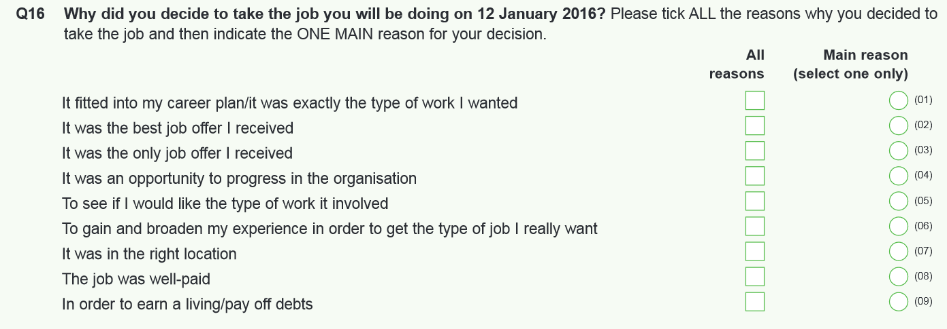
A key motivation behind this question is to understand whether a job role is part of a plan. There is evidence that leavers with lower-level SOC-code jobs often answer indicate that the job is part of a career plan. This should be seen as a positive destination, but is arguably a little hidden in the data. One possibility would be to surface the leaver’s self-assessment of being on-track using a mechanism such as a 5-point Likert scale question that asks “are you where you want to be” or “are you where you expected to be”, to elicit a general sense of satisfaction with progress. Views are sought on this general approach and the Review would welcome advice on this point.

How a job opportunity was located
This question has long been collected by HEPs. We would welcome views on its continuing usefulness.
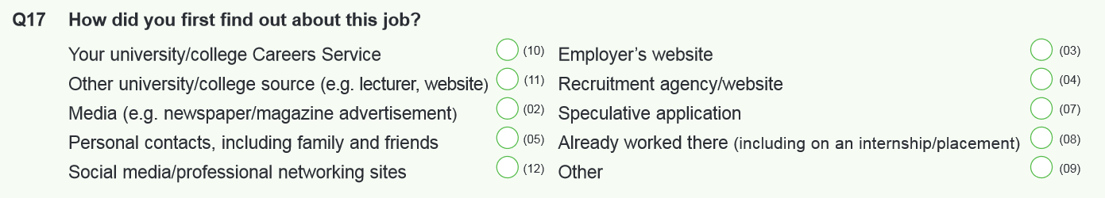
If retained, this question might benefit from the addition of a valid entry focused on leavers working in the ‘gig economy’ by obtaining work from specialized labour-sourcing online platforms.
There is interest in increasing our understanding of how leavers use social capital when finding jobs, and the role that universities play in this.
We welcome general comments to inform our approach in this area.

Placements
Some data on placements during study are currently collected through the DLHE (such as in Q.15). However, the data is limited in detail. There are now requirements from a wide range of data users to understand work-based learning/activity during study, and we believe that more detailed information is required. This would enable more meaningful links to be made between work-based learning and later employment. For work-based placements and sandwich courses (possibly also for internships and apprenticeships) the location, duration and organization should be collected as a minimum. Other areas of interest include remuneration, credit earned and how the experience was sourced.
Furthermore, we contend that the increased importance of these data and the time-lag involved, make collecting these data through a leavers’ survey sub-optimal. Placement data should instead be collected in the HESA Student record, to ensure the data are authoritative, structured and timely. It is possible that if a suitable mechanism can be found, questions (like current DLHE’s Q.18 and Q.19) which seek to make links between current and previous employment could be replaced with data-linking back to the HESA Student record.
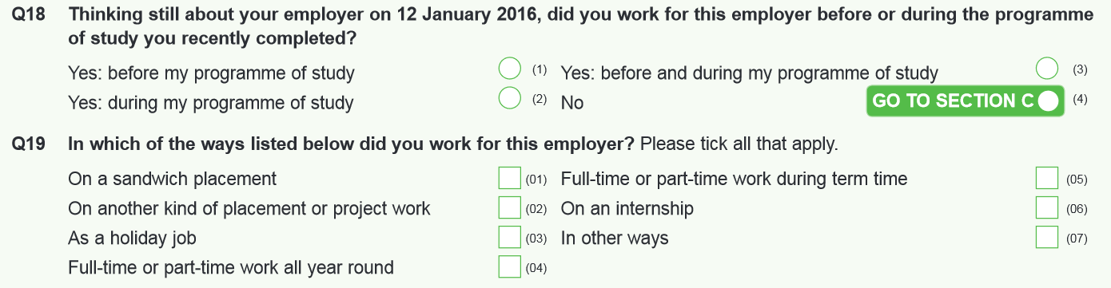
We welcome respondents’ views on the overall approach described above, and scope of the data that should be collected.
Some data users have expressed an interest in broadening data collection to include work-related learning in the curriculum. This would require an appropriate classification scheme as a wide range of educational experiences could be categorized as work-related, including:
- Guest industry lectures
- Work simulations
- Work shadowing
- Employer/industrial visits
- Having an employer mentor
- Live projects set by employers
Responses are sought on the approach that should be taken in this area, including any comments on feasibility.

Non-placement work
There remains one area of employment-related information that could be usefully collected from a leavers’ survey, and that is to determine whether leavers had worked in a capacity not related to their study during their period of study. Another possible source for these data would be in a survey around the time of graduation. These data would complete the ability of data collectors to understand links between work activity during study and later employment. Specifically, leavers should be asked if they had a job or volunteered during their course. There would be additionasl value in understanding the nature of employment and the reasons for undertaking it, particularly in the case of part-time students. We welcome comments on this area to inform our approach.

Employment in particular professions (including teachers and NHS employees)
Some professions conduct surveys shortly after entering into employment. The DLHE has traditionally assisted in links being made between these professional surveys and previous study, by asking tailored questions. In future, it may be possible to establish some of these links using HMRC data, and we will investigate the possibilities for this.
Furthermore, a similar approach (either through HMRC or bespoke questions) may be desirable in other professions besides teaching and healthcare, where PSRBs may wish to link their own entrants’ surveys back to study information, or to understand the effects of accreditation on later employment. One other possible mechanism for achieving a higher level of linking to later professional employment would be through the collection of a wider range of accreditation information within the curriculum information in the HESA Student record.
There may also be value in ‘decliners’ information – finding out why students who elected not to go into the profession for which their study prepared them, made this choice.
We welcome exploratory comments on any of the above, particularly from professional, statutory and regulatory bodies.

Further study, training and research
There is significant interest in returners to study, and in future, data linking to HESA and other education datasets creates the possibility of deriving much of the factual information captured from respondents via this method.
Questions 25 through 29 could be removed by linking back to current HESA data. We do not know how viable it would be to answer similar questions from FE datasets, to account for non-linear progression. We would like to gauge the general level of support for this general approach, and to receive comments about how it could best be implemented.
This potentially-powerful data-linking opens the question of whether this area of questioning should be removed from the survey entirely. An alternative to this would be to ask higher-value questions about motivations for study, in order to better understand student plans. For instance, a question that asked the student to comment on all the different reasons for study, and then to pick the main one, would be a valuable source of information for a wide range of uses and users. A question of this kind would need careful design to ensure neutrality and avoid a possible vulnerability to post-hoc rationalization. We would welcome comments on this issue, and particularly welcome views on the categorization of motivations for further study.

Overall HE experience
The current DLHE contains some questions about overall HE experience.
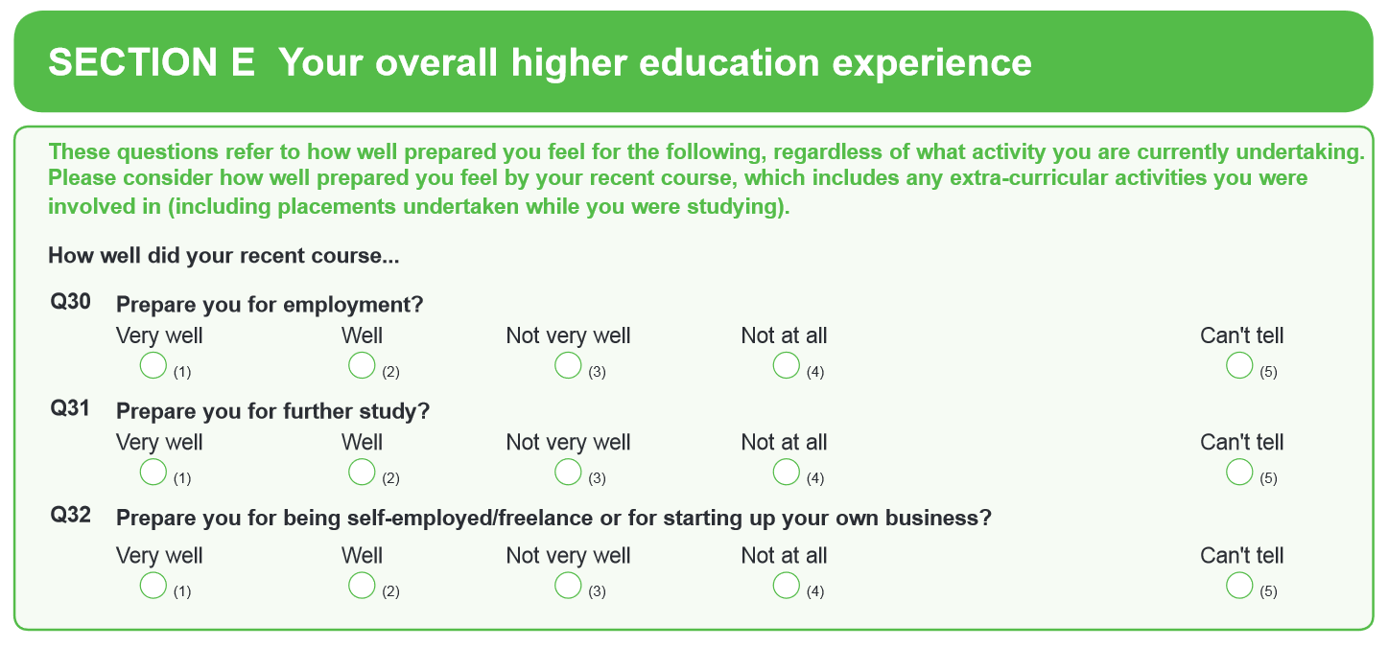
While tackling an important set of questions around skills and preparedness, this section of the DLHE survey has been roundly criticized for asking what are essentially hypothetical questions of leavers who will, in the main, have only theoretical knowledge of post-study paths they have not taken. Moreover, the data produced by these questions are not amenable to consideration against the intended learning aims of a course, since these do not currently exist as structured data at national level. In a nutshell, a vocational course in say, Nursing may perhaps not be intended to cover entrepreneurship in a meaningful way. Asking a nurse this question will likely yield answers that might be predicted from the course aims. Conversely, if the question yields answers that are not predictable from the course aims, more questions are raised than are answered. These superficial questions should therefore be replaced with a more useful set of questions around skills development and use (as discussed above) and graduate entrepreneurship (as discussed below).
Alternatively, the questions might retain value if leavers were only asked the question that applies to their present situation – but this is not part of the working proposal.
We would like to gauge the general level of support for this proposal to remove these questions, and also welcome comments.

Graduate enterprise
We have already covered graduate enterprise superficially in the Activity section, above. We now seek to explore this in more detail. There is wide-ranging interest in the characteristics of graduate entrepreneurship. This is an area where linked data may not assist our understanding a great deal, as early-stage graduate entrepreneurs may not be represented (or fully represented) in either tax or welfare records, for a variety of legitimate reasons.
Areas of interest are the industry of the start-up, and the source of funding behind it. There may be interest in gathering other business information, like the web address, or any linkable business information (companies house number, for instance).
Questions such as these could be ‘routed’ from appropriate answers to the Activity question.
We welcome comments on this overall approach, and welcome suggestions for the scope of these data.

Leavers’ self-perception of outcomes
The leaver is arguably the best judge of success. The current DLHE does not capture self-evaluation by the leaver. We judge that this omission should be corrected, as SOC code and salary present a narrow view of what represent successful outcomes from HE. HE arguably has a wide range of positive outcomes, of which employment-related ones are only a sub-set. Economic indicators are easily counted, but other important areas of benefit and value could be susceptible to measurement, and so we have concentrated our resources in this area. Elsewhere we have described the research we that has been commissioned into gathering richer student views, and analyzing the literature around value from HE.
The Review has also undertaken some initial exploration of possible mechanisms for capturing these data in ways that are amenable to rigorous quantitative analysis. This could have the effect of widening the range of indicators available for use in public information products. We understand the great care that is required, and would welcome comments about the general approach to inform a suitably cautious approach in this area.
Below, we present some initial work by the Review, by way of some initial options that could be worthy of further exploration.

Student engagement
The HE Academy have piloted the UK Engagement Survey. Engagement is often regarded as a significant leading indicator for good academic outcomes. Evidence from universities that track this, including through graduation surveys, find that very highly satisfied students/graduates often engaged fully with provision offered by their university, developed employability skills alongside academic qualifications and have chosen for a variety of reasons to be where they are at the point of the current DLHE survey. Might engagement prove to have other post-study benefits? We welcome comments on the value of either linking back to UKES data, or asking engagement-related questions in a future replacement for DLHE.

Net Promoter
<Approach to be discussed separately when considering David Hutton’s paper>

Wellbeing
We are indebted to the work of Dr. Glen Crust for our initial investigations in this area.
<Approach to be discussed separately when considering Glen Crust’s paper>

Skills
We have thus far discussed skills as they relate to employment, but it satisfaction with the extent to which learned skills are being utilized could also be measured, possibly by explicitly asking a follow-on question in the Skills section that asks the leaver to rate satisfaction with this, perhaps using a 5-point Likert scale.

Links back to the NSS
One suggestion the Review group has heard is that an explicit link back to some of the National Student Survey (NSS) questions might allow for improved analysis. By asking questions that are analogous to NSS questions 19-22 we could discover to what extent perceptions of preparedness, confidence and satisfaction have changed following study.
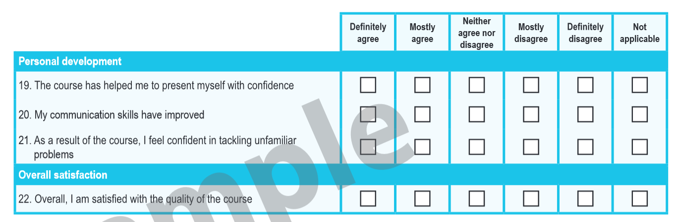

Other self-assessment possibilities
Not all relevant points may be captured using the frameworks in the discussion above. There may be merit in a general satisfaction measure that seeks to answer to what extent the leaver is happy or satisfied with their current situation. We also recognize that the answers given to questions such as these will be impacted by the timescales for a survey, covered elsewhere. Though further research will be done in this area, we welcome any advice or comments on alternative mechanisms that would have value.

General discussion on structure and approach
Throughout the above discussion, two underlying facts become clear.
Firstly, the possibilities opened-up by data-linking are powerful, and could play a significant role in driving-up the completeness, consistency and timeliness of the data.
Secondly, data linking on its own will be insufficient to meet the requirements of data collectors. Some form of survey activity will certainly be required. There is, however, an opportunity to increase the value of a survey by asking questions relating to motivation and evaluation, which will contextualize linked data
Separate to discussions of the content of the survey, we have also observed that the structure of any replacement survey could be improved over that of the DLHE, to make the questions flow more easily. To take account of the potential changes discussed above, questions could be grouped and ordered as follows:
- a section that deals with factual information about activity
- a section that deals with motivations behind activity
- an evaluative section that deals explicitly with perceptions of destinations and outcomes.
In some cases this will be difficult to achieve, as some questions have natural follow-on questions that are of a different character. However, in general terms, we believe any future survey would be improved over current DLHE by building-in a more natural conversational ‘arc’ to the ordering of the questions, and we welcome feedback on this intention.
We welcome general comments on this approach.

Compiled by Dan Cook (HESA), based on exploratory work by Charlie Ball (HECSU), Terry Dray (Liverpool John Moore University/AGCAS), Richard Puttock and Darren Watson (HEFCE) and Andrew Whitmore (University of Manchester)

